1. new code for handling missing columns from table
FiveDimesParser.java on line no 938
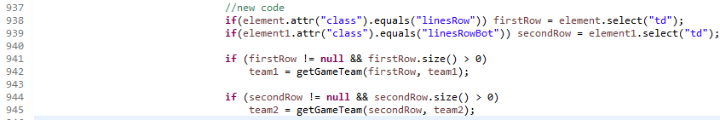
And in method getGameTeam() modified
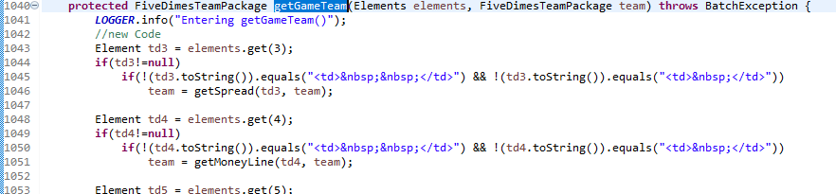

2. Code for TeamTotal Event
A) New entity class named TeamTotalRecordEvent added in Project CommonPackage, inside package named com.ticketadvantage.services.model .

B) Below line of code is added in FiveDiemsProcessSite on line no 218
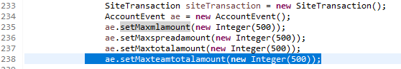

C) fields teamtotaljuice, teamtotalindicator, teamtotal and maxteamtotalamount added in AccountEvent.java
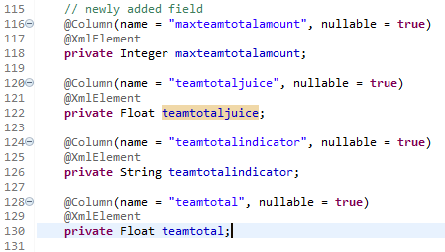

D) In FiveDimesTeamPackage.java new field named teamTotalMax added
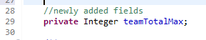
E) in FiveDimesEventPackage.java new field named teamTotalMax added
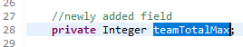
F) In FiveDimedParser setter method call is added
G) In FiveDimesParser.java new methods named
getTeamTotal() added at line no 1241 and getTeamTotalSecond() method added on line no 1287

H) In Super class SiteTeamPackage.java new fields mention below are added
gameTeamTotalInputId, gameTeamTotalInputName, gameTeamTotalInputValue, gameTeamTotalSelectId, gameTeamTotalSelectName, gameTeamTotalOptionValue

gameTeamTotalInputIdSecond, gameTeamTotalInputNameSecond, gameTeamTotalInputValueSecond, gameTeamTotalSelectIdSecond, gameTeamTotalSelectNameSecond, gameTeamTotalOptionValueSecond

gameTeamTotalOptionIndicator, gameTeamTotalOptionNumber, gameTeamTotalOptionJuiceIndicator, gameTeamTotalOptionJuiceNumber
gameTeamTotalOptionJuiceNumberSecond, gameTeamTotalOptionJuiceIndicatorSecond, gameTeamTotalOptionNumberSecond, gameTeamTotalOptionIndicatorSecond,

I) In SiteParser.java methods parseTeamTotalSelectOption() added on line no 1207
new method named parseTeamTotalSelectOptionSecond() added on line no 1243
new method parseTeamTotalData() added on line no 1279
and method parseTeamTotalDataSecond() added on line no 1363

J) In FiveDimesProcessSite.java else if clause added to process TeamTotalRecordEvent() on line no 755

K) in SiteProcessor.java new method named getTeamTotalTransaction() added on line 1637 and new method name determineTeamTotalTransactionData() added on line 1660
new method named createTeamTotalTransaction() added on line no 1694

L) In SiteWagers.java method named setupTeamTotals() added on line 727
new method named determineTeamTotalData() added on line no 845
new method name populateTeamTotalData() added on line no 902
new method named determineOver() for processing TeamTotalRecordEvent added on line no 1292
new method name determineUnder() added for processing TeamTotalRecordEvent object on line no 949

M) in BatchErrorCodes.java new error code added

N) In BatchErrorMessage.java new message added

3. Alternate Price Changes
In SiteProcessor.java method previewEvent() has call to finalOrder() method which is setting an alternate value.
So this call to method finalOrder() is commented. And just to select the default value of website which is at index 0. Thus, variable finalnumber is initialized to 0 and used.

4. First Half Table selection
New Code added in FiveDimesParse.java in method parseGames() on line no 194
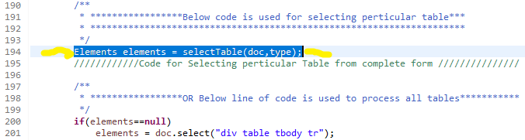

New method selectTable() is added in FiveDimesParser.java on line no 217
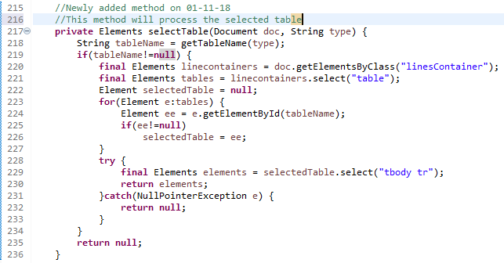
New method named getTableName() in FiveDimesParser.java for getting table id added on line no 240
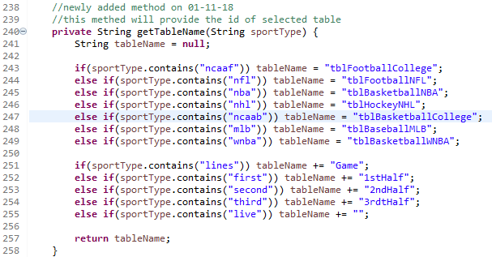

Database Modification in Table accountevent new colums needs to add as show in below image
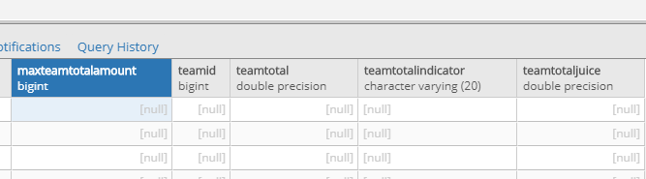

5. Team Total Selection for Pinnacle Site
Betpreview.html new entry for TeamTotal Radio button on line no 48
In betpreview.js to make over and under selection visible jquery code added on line no 140
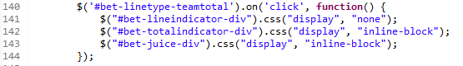
In betpreview.js function named getTheGameData() if condition modified
To consider teamtotal on line no 104
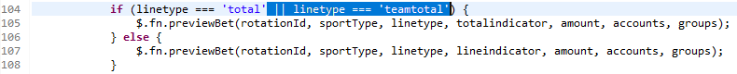
In placetransaction.js function named previewtransaction() on line no 69 if condition is modified
no line no 68 to consider teamtotal
In betpreview.css
To adjust the width on ui width modified on line no 86 and 148
In SiteProcessor.java new else condition added for processing teamtotal on line no 451
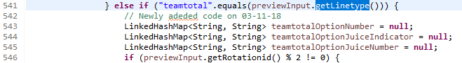
In SiteEventPackage.java new entry for teamTotalMax added on line no 46
In PinnacleAPIParser.java new if condition added to set set maxteamTotal on line no 441
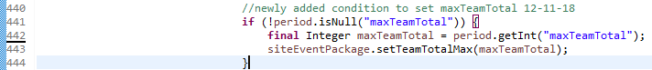

In PinnacleAPIParser.java new if condition to set temtotal value added with a method call on line no 463
New method named getTeamTotalData() added on line no 612
For setting team1 teamtotal data and team2 teamtotal data methods added SetTeamTotalData() on line no 643

Miscelleneous Changes
- Javax Servlet Dependancy added in POM.xml of TicketAdvantage
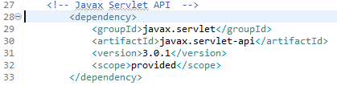
2. HTTPClientWrapper.java System.out.println() added on line 1775 just for eclipse console output
